Nepal College of information Technology
Imadol lalitpur
Unit Test Spring Semester 2006

Program : BE Semester: Spring
Time : 2hrs Year : 2006
Full Marks: 66
Engineering Math-IV
Attempt all questions

1. a) Find Z-transform of 7
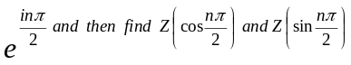

b) If F(z) and G(z) are respectively the Z-transform of f(t) and g(t) then z[f(t)* g(t)] = F(z). G(z) 8

Or

Find Z-transform of (i) 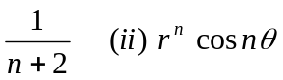
2. a) Find the Inverse Z-transform of 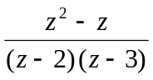 8
b) Solve using Z-transform:- 7
y_{x+2} -3y_{x+1} +2y_{x} = 0 Where y₀ = 0 y₁ = 0

3. a) Prove:- Z(a^{n}) = 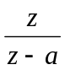 4
b) Find harmonic conjugate of u = y³ - 3x²y. 7
c) Show that 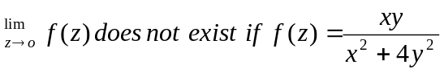 and
f(0) = 0 4

4. a) Let function f(z) = u(x,y) + iv (x,y) be defined and continuous in some neighborhood of point z = x + iy and differentiable at z itself. Then at that point u_{x} = v_{y} and u_{y} = - v_{x} 7

Or

Integrate 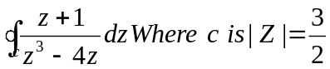
b) Integrate 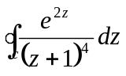 where c: |Z| = 4 counterclockwise 8
5. Attempt all
i) Check analyticity for f(z) = e^{x} (cosy + i siny)
ii) Express 1 + tanα in a polar form

